

**FACULTY OF COMPUTER AND MATHEMATICAL SCIENCES**

**CS251 – BACHELOR OF COMPUTER SCIENCE (HONS) NETCENTRIC COMPUTING**

**ITT544 – WEB TECNOLOGY**

**MANUAL BOOK SUPPLIER SYSTEM**

**PREPARED FOR:**

**MOHD ALI BIN MOHD ISA**

**PREPARED BY:**

|  |  |
| --- | --- |
| **NAME** | **NO MATRIK** |
| **NURUL NADIATUL FITRAH BINTI ROSDI** | **2018638952** |
| **JULIANA BINTI MUHAMMAD JUFRI** | **2018645358** |
| **NOORSYAFIQAH BINTI BAJURI** | **2018440452** |
| **JULIA FARZANA BINTI MOHD NAZRI** | **2018262088** |

**GROUP: M3CS2514B**

1. Login Form

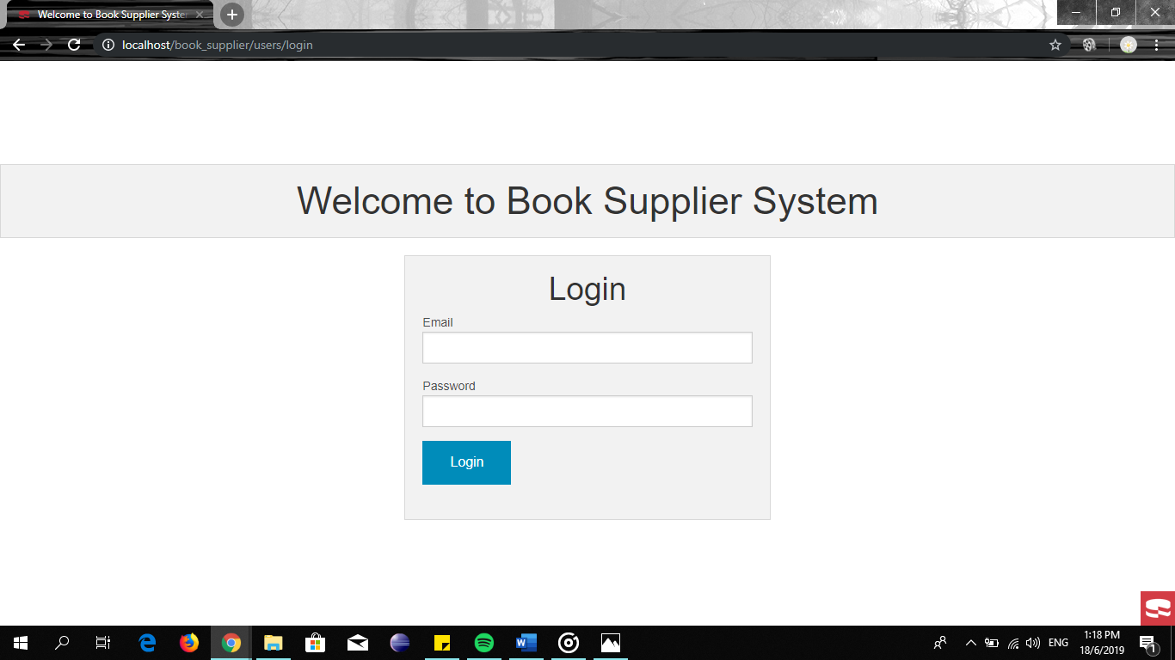

User login

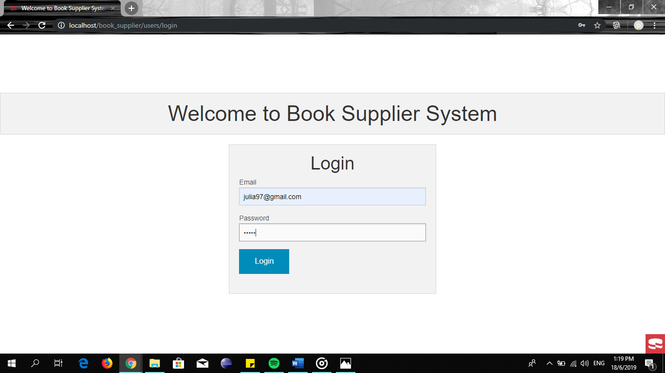

|  |  |
| --- | --- |
| Website Content | Description |
| LOGIN | Book supply system for staff login that is admin to this system |

LOGIN PAGE

1. Open browser (EI, Chrome, Explorer) from your local computer
2. To log in type URL
3. Book Supply system will prom login page
4. Fill the require data such as email and password to gin to the system.

USER

Users List

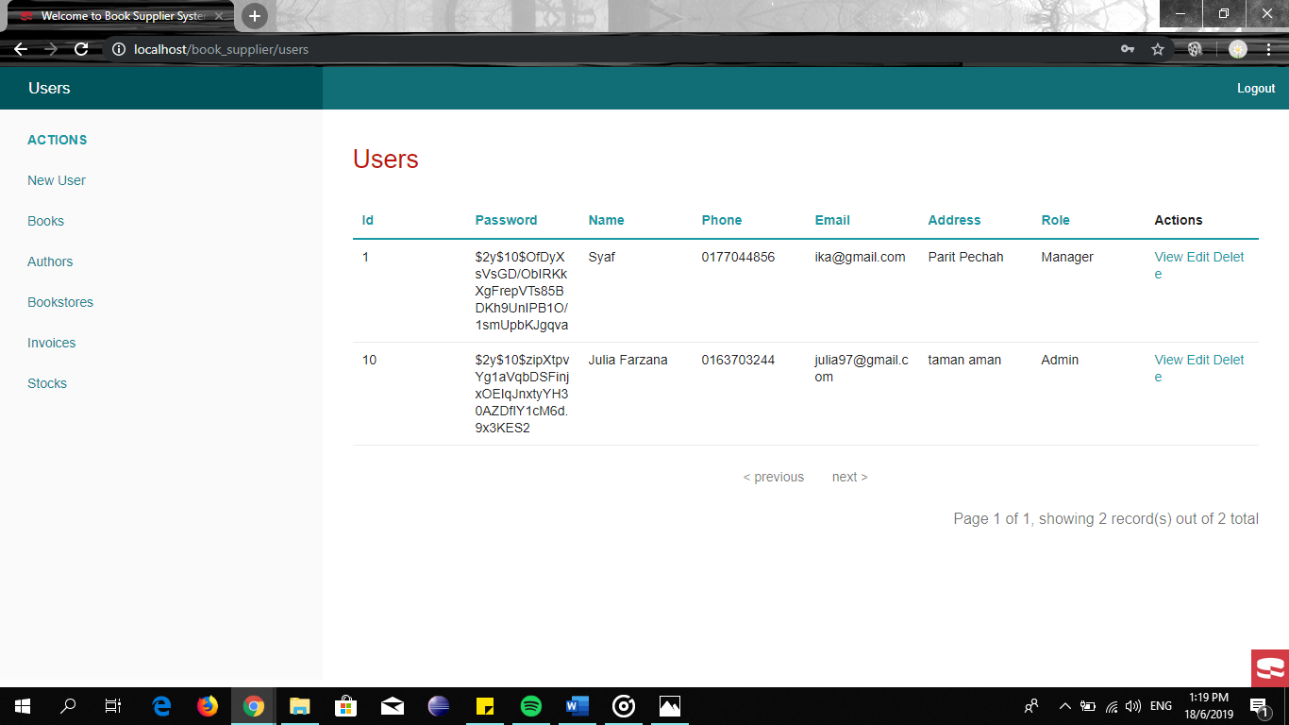

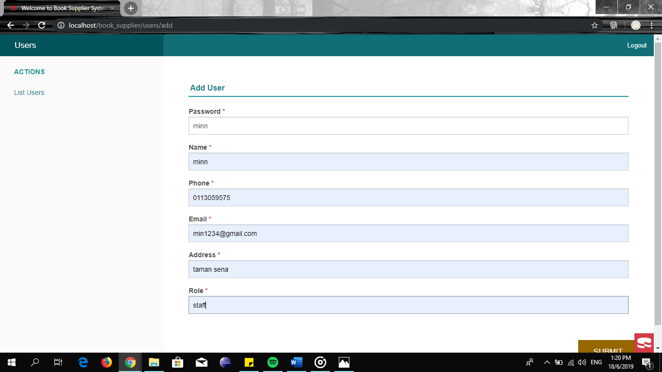Add new use

View detail about user with id 11

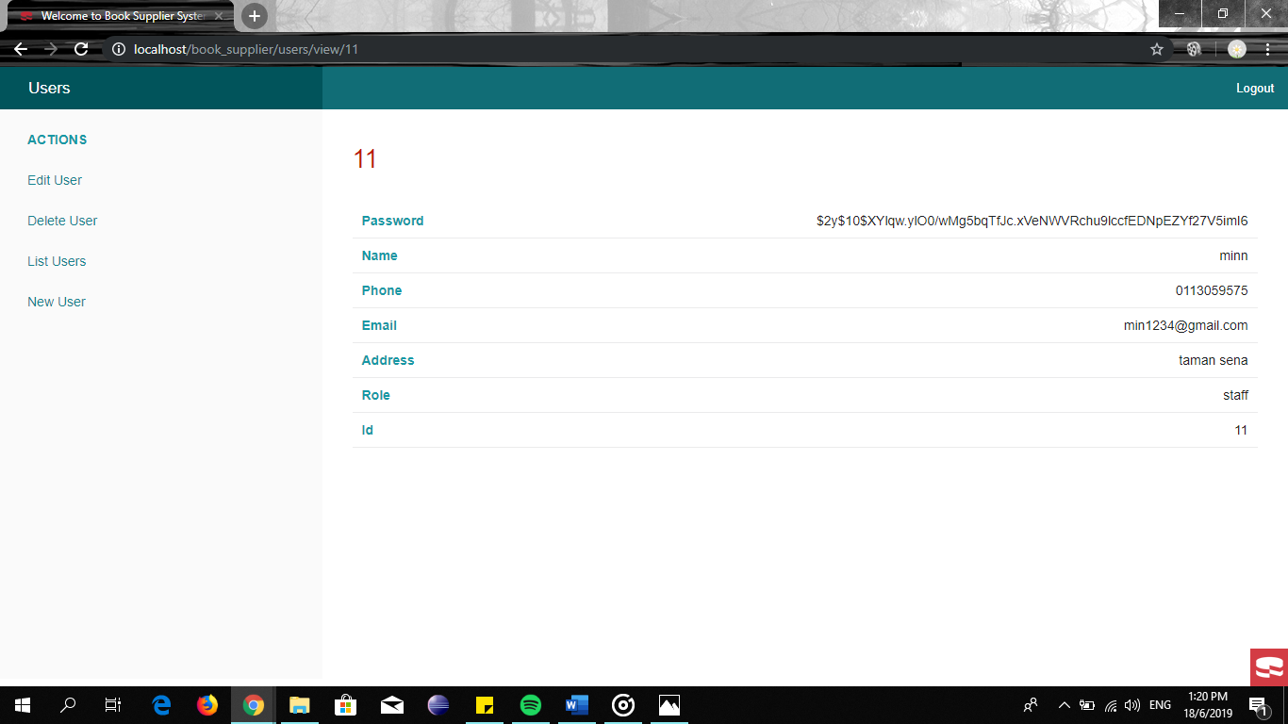

Edit user

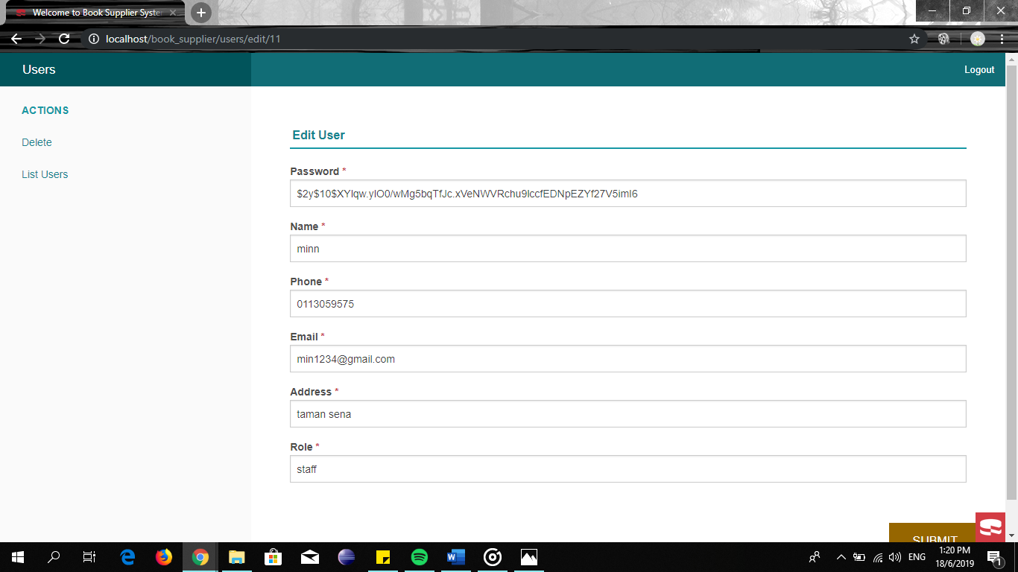

BOOKS PAGE

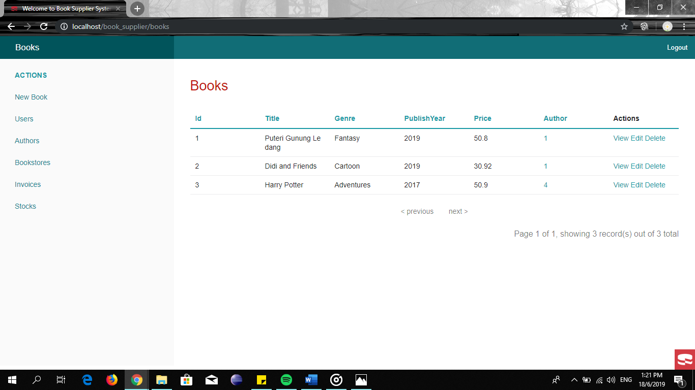

View books id=1

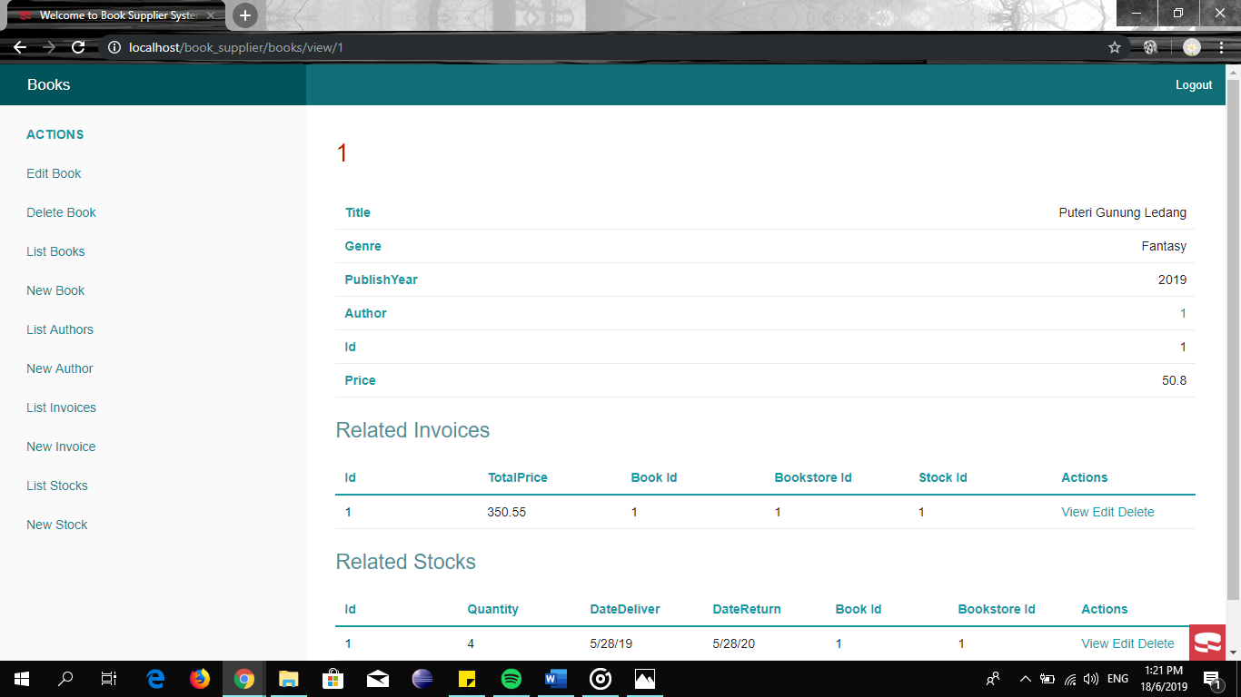

Edit books

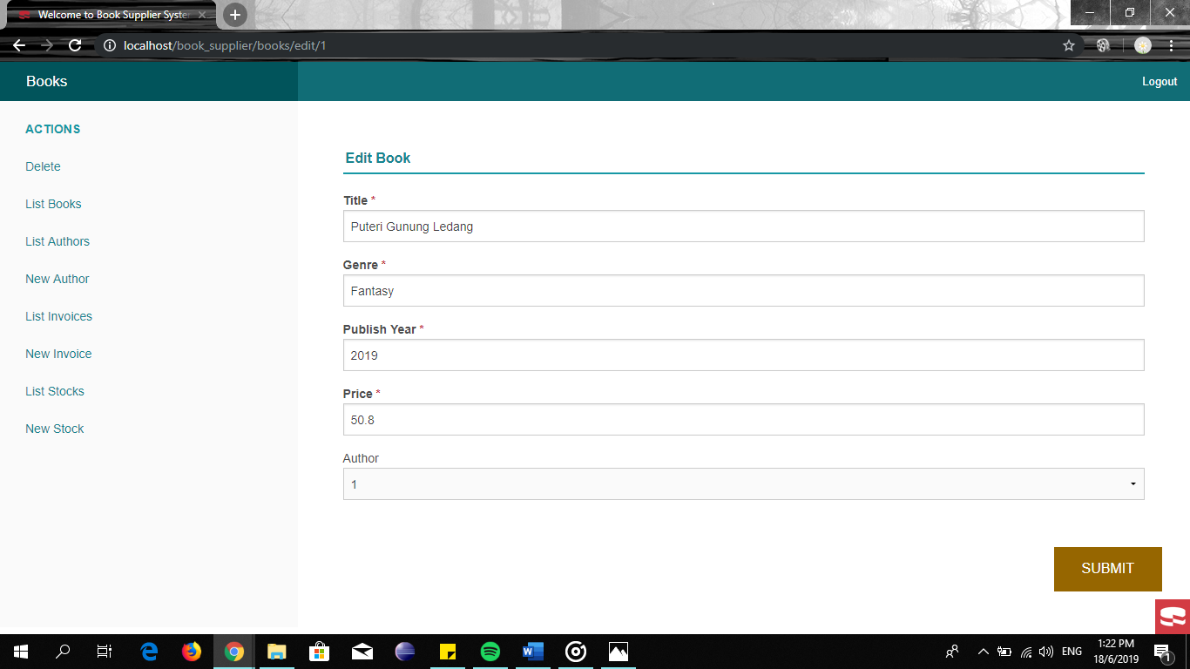

Delete books

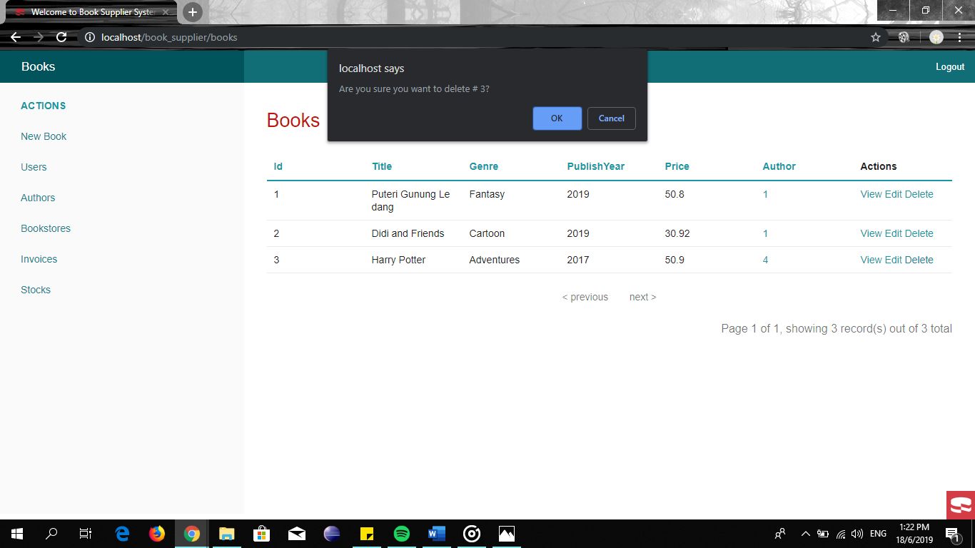

AUTHORS PAGE

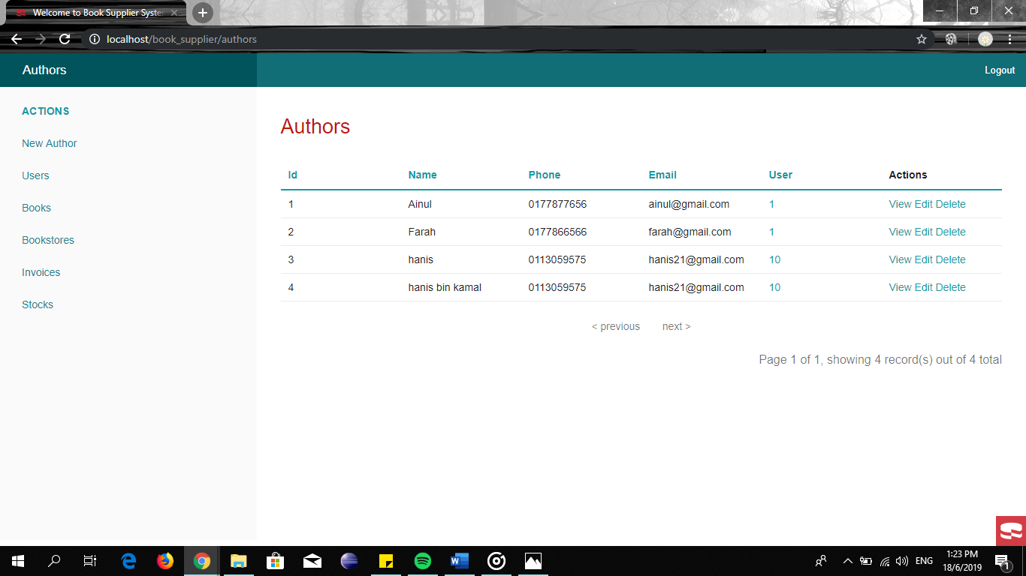

View author

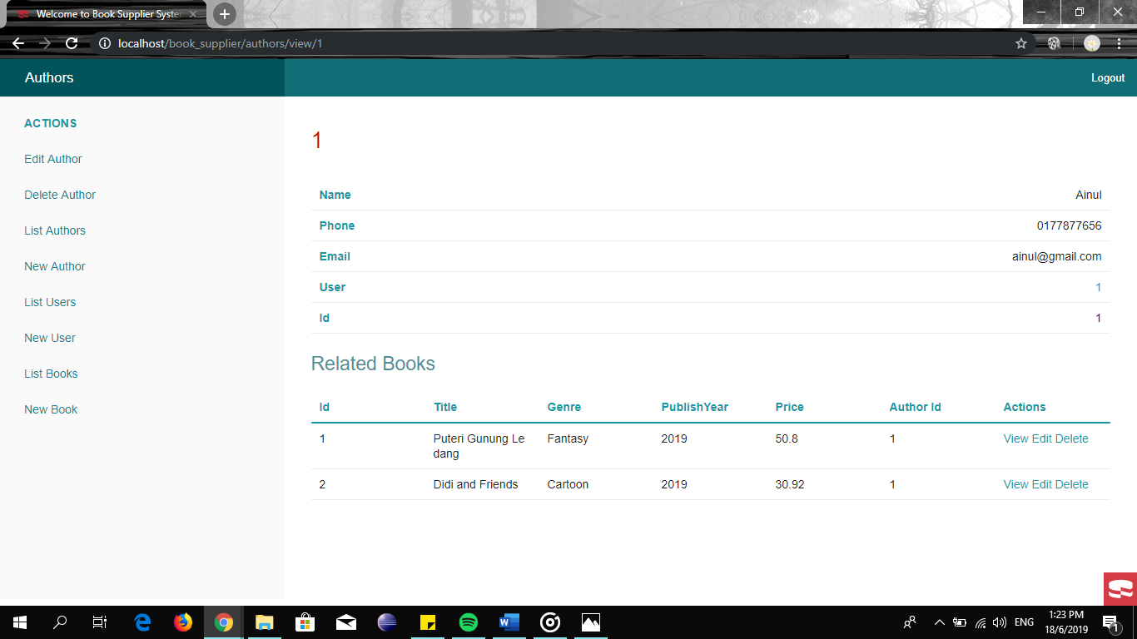

Edit author

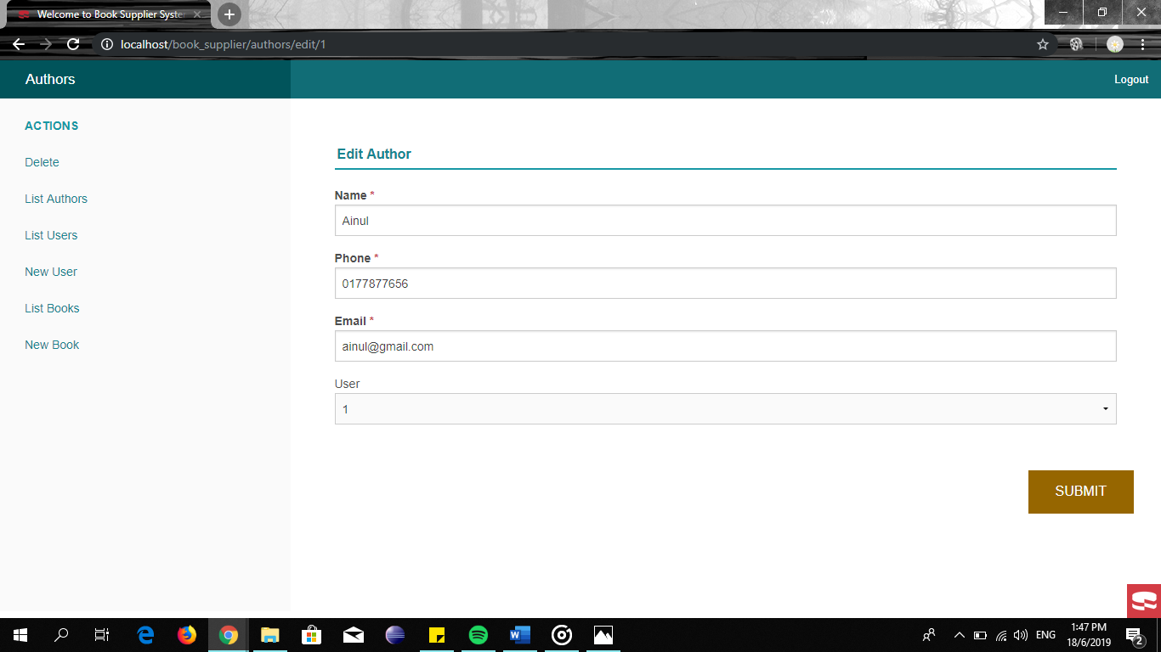

BOOKSTORES PAGE

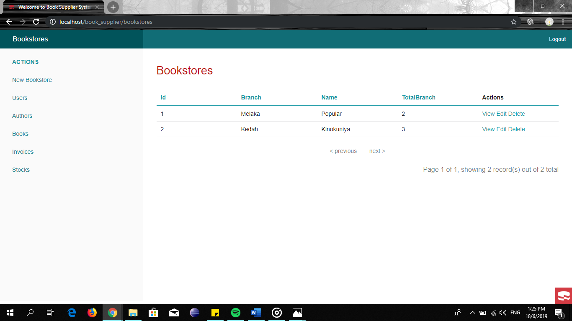

View bookstores

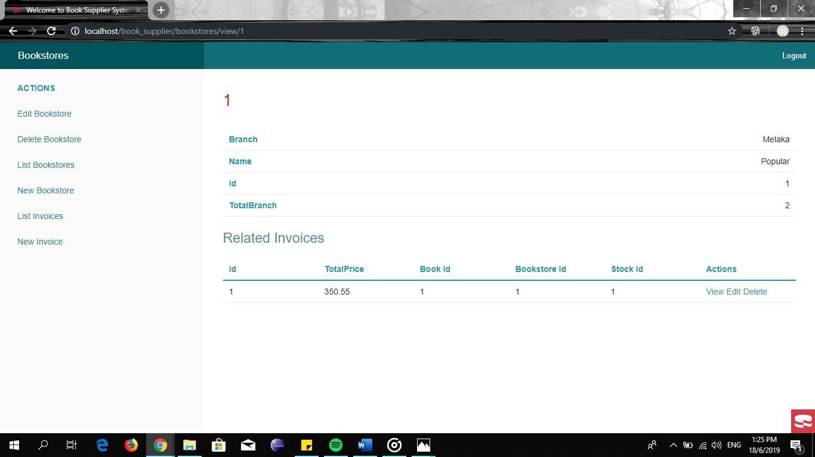

INVOICES PAGE

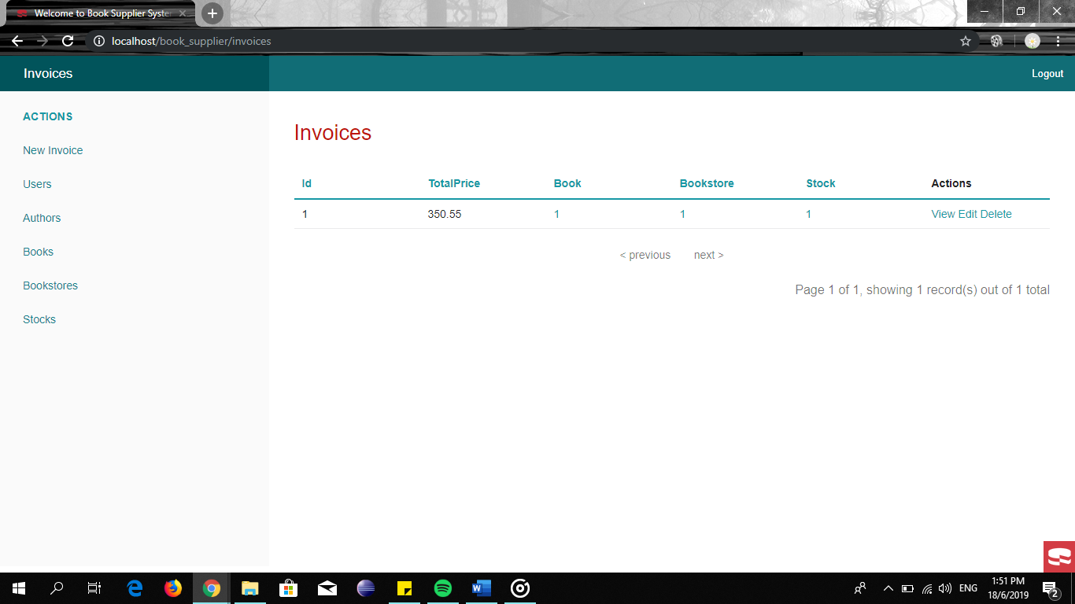

View invoices

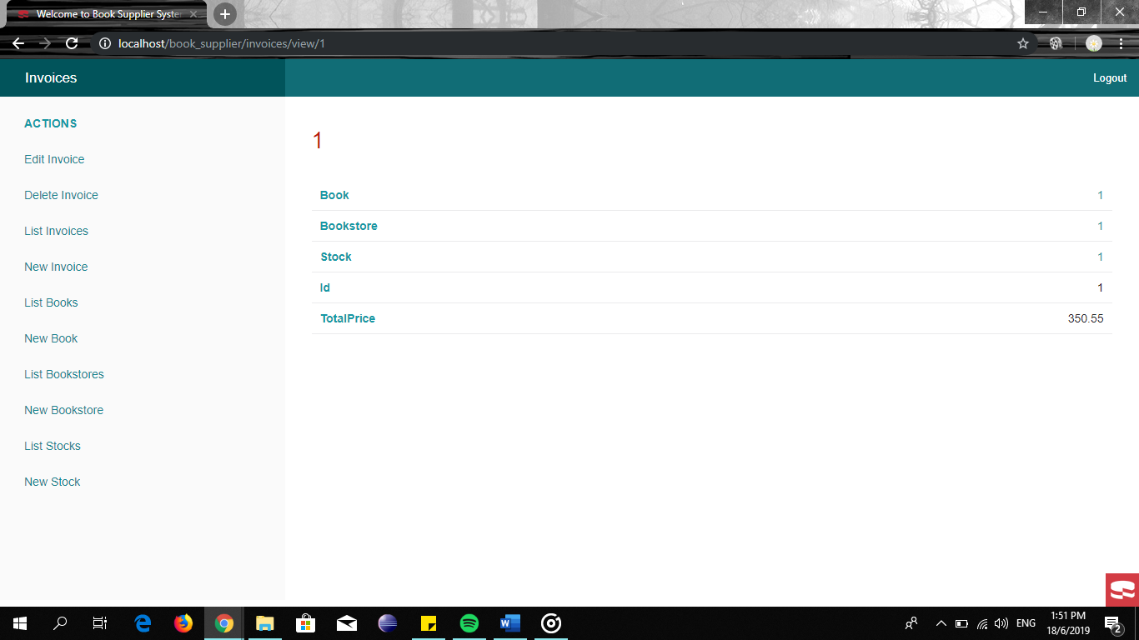

STOCKS PAGE

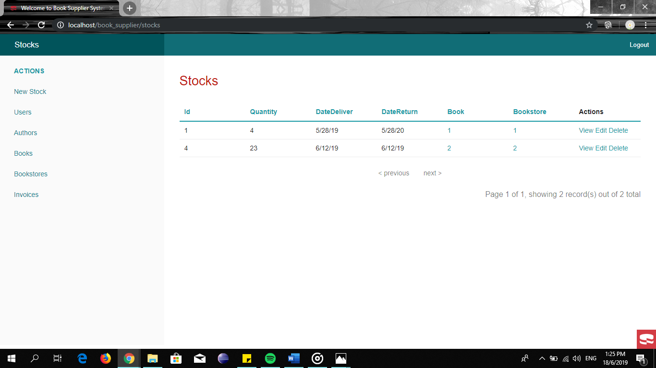

View stocks

